Online-training/workshop report

A one day workshop was organized by National Center for Natural Resources, Pt. Ravishankar Shukla University Raipur for basics of LC-MS-MS, dated November 05, 2022 at 11.00 am in online-mode. The program was inaugurated by Prof. M. K. Deb, Director of NCNR, Pt. Ravishankar Shukla University, Raipur. Dr. Shravan Tiwari and Dr. Vivek Sharma and other distinguished guests have participates and gave the lecture on his particular topics (basics of LC-MS-MS) in this one day online workshop. In addition, in this program the numbers of faculties, students and research scholars from Pt. Ravishankar Shukla University Raipur have participate for the same. The program aimed to encourage the young Research Scholars and Students and gave the fundamental and basic knowledge on advanced and modern technique (LC-MS-MS) to have handling and performed the experiments.
Some photograph during the session
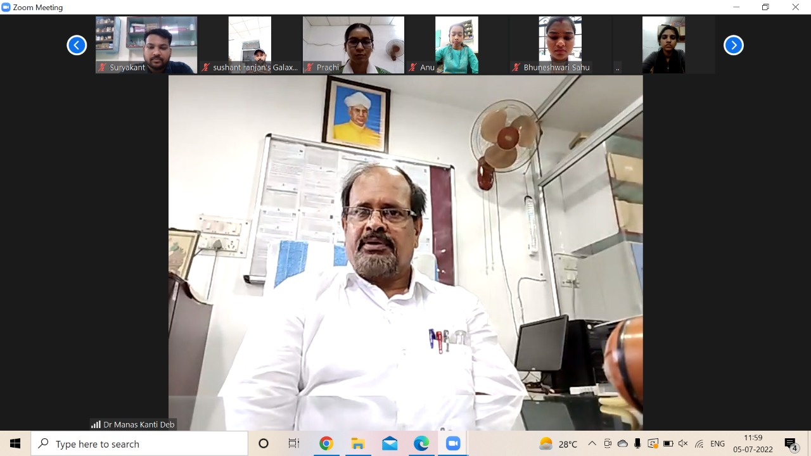

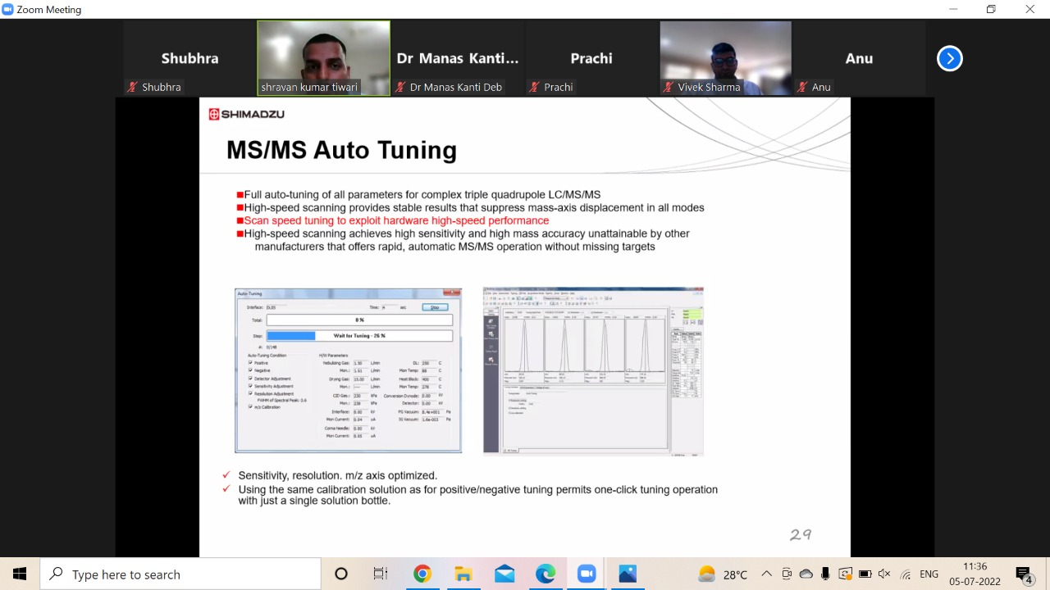

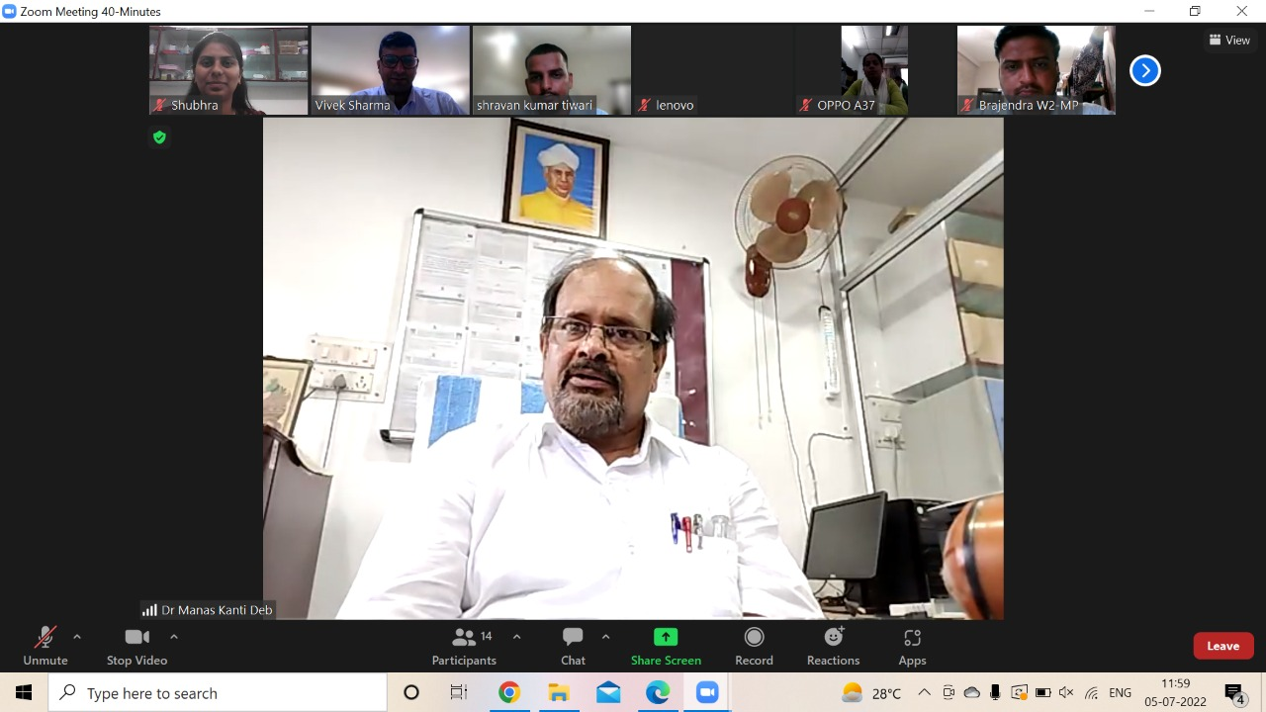

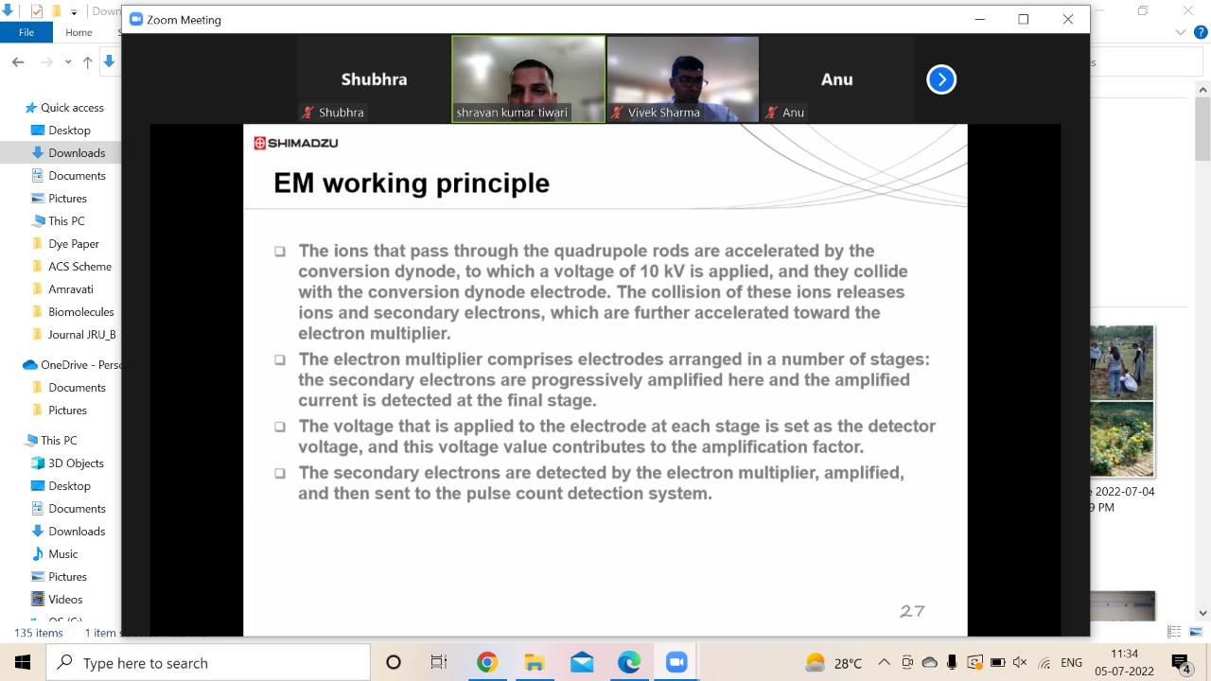
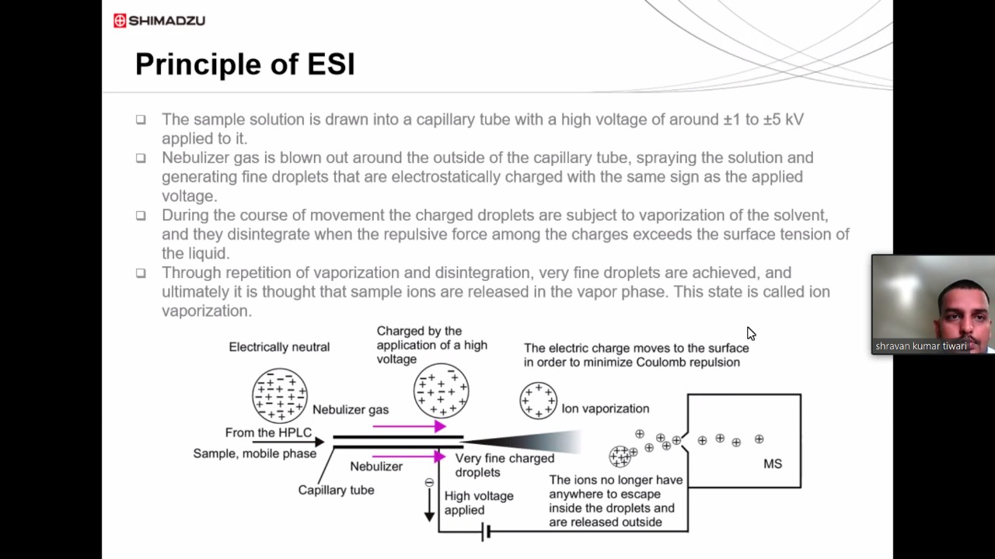

Dr. Ramsingh Kurrey  (Post-Doctoral Fellow) | Prof. Manas Kanti Deb  Director, NCNR

