Chemistry Laboratory:
Facilities:
Modular Chemistry laboratory is equipped with all best quality instruments for undergraduate set-up. Equipment includes UV-Vis Spectrophotometer, Suface-tensiometer (both manual and motorized), Flame-photometer, Nephlometer, colorimeters, pH-meters, Conductivity meters, Potentiometers, Thermostates, Clevenger’s apparatus, Electronic balances, Microwave Oven and Hot air oven, Micro-pipettes, Muffel furnace, Fume hood etc.

Laboratory Sessions:
Students are first introduced to safety measurements in chemistry laboratory then introduction to common glassware and analytical balances, calibration of common glassware and other instruments. Students are also made familiar to techniques and skills required to perform experiments involving titrations, kinetics, synthesis, isolation, extraction etc. Investigation of experimental problem through project work (involving working out the problem statement, planning experimental procedure, data collection and its analysis and writing report)

Glimpses of Chemistry Laboratory
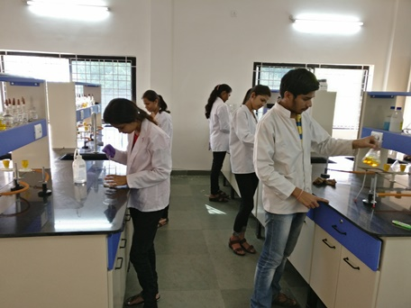 |  | 