The Annual Quality Assurance Report
2015-2016
Submitted by
Pt. Ravishankar Shukla University
Raipur-492 010, Chhattisgarh

Submitted to
National Assessment and Accreditation Council
Bangalore

AQAR 2015-16
July 1, 2015 to June 30, 2016

The Annual Quality Assurance Report (AQAR) of the IQAC

All NAAC accredited institutions will submit an annual self-reviewed progress report to NAAC, through its IQAC. The report is to detail the tangible results achieved in key areas, specifically identified by the institutional IQAC at the beginning of the academic year. The AQAR will detail the results of the perspective plan worked out by the IQAC. (Note: The AQAR period would be the Academic Year. For example, July 1, 2012 to June 30, 2013)

Part – A

1. Details of the Institution:
1.1 Name of the Institution: |  |  |  | Pandit Ravishankar Shukla University
1.2 Address Line 1: |  |  |  | G.E. Road
City/Town: |  |  |  | Raipur
State: |  |  |  | Chhattisgarh
Pin Code: |  |  |  | 492 010
Institution e-mail address: |  |  |  | Vice Chancellor: vc_raipur@prsu.org.in; proskp@gmail.com  Registrar: registrarprsu@gmail.com; dharmesh.sahu@yahoo.co.in
Contact Nos.: |  |  |  | VC: +91-771-2262857; +91-9424200857  Registrar: +91-771-2262540; +91-7587151099
Name of the Head of the Institution: |  |  |  | Dr. S.K. Pandey
Tel. No. with STD Code: |  |  |  | +91-771-2262857
Mobile: |  |  |  | +91-9424200857
Name of the IQAC Co-ordinator: |  |  |  | Dr. Atanu Kumar Pati
Mobile: |  |  |  | +91-9826654829
IQAC e-mail address: |  |  |  | iqac@prsu.org.in; iqacprsu@gmail.com; akpati19@gmail.com
1.3 NAAC Track ID  (For ex. MHCOGN 18879) |  |  |  | CHUNGN10085
1.4 Website address: |  |  |  | http://www.prsu.ac.in
Web-link of the AQAR:  For ex. http://www.ladykeanecollege.edu.in/AQAR201213.doc |  |  |  | http://www.prsu.ac.in/AQAR201516.doc

1.5 Accreditation Details:
S. No. | Cycle | Grade | CGPA | Year of Accreditation | Validity Period
1 | 1st Cycle | B⁺ | - | 2003 | 5 years [2003-2008]
2 | 2nd Cycle | B | 2.62 | 2011 | 5 years [2011-2016]
3 | 3rd Cycle | NA | - | - | -
4 | 4th Cycle | NA | - | - | -

1.6 Date of Establishment of IQAC: |  |  |  | 27/11/2003
1.7 AQAR for the year (for example 2010-11): |  |  |  | AQAR 2015-16
1.8 Details of the previous year’s AQAR submitted to NAAC after the latest Assessment and Accreditation by NAAC (for example AQAR 2010-11 submitted to NAAC on 12-10-2011):
i | AQAR 2010-11 | 25/09/2011
ii | AQAR 2011-12 | 30/09/2012
iii | AQAR 2012-13 | 09/10/2013
iv | AQAR 2013-14 | 07/12/2015
v | AQAR 2014-15 | 07/12/2015
vi | AQAR 2015-16 | 27/11/2015

1.9 Institutional Status:
University |  | State Central Deemed Private
Affiliated College |  | Yes No
Constituent College |  | Yes No
Autonomous college of UGC |  | Yes No
Regulatory Agency approved Institution (e.g., AICTE, BCI, MCI, PCI, NCI) |  | Yes No
Type of Institution |  | Co-education Men Women
 |  | Urban Rural Tribal
Financial Status |  | Grant-in-aid UGC 2(f) UGC 12B  Grant-in-aid + Self Financing Totally Self-financing

1.10 Type of Faculty/Program:
Arts |  | Science |  | Commerce
Law |  | PEI (Phys Edu) |  | TEI (Edu)
Engineering |  | Health Science |  | Management
Life Science |  | Law |  | Social Science
Technology |  | Home Science

1.11 Name of the Affiliating University (for the Colleges): Not applicable
1.12 Special status conferred by Central/ State Government - UGC/CSIR/ DST/ DBT/ ICMR etc.:
Autonomy by State/Central Govt. / University
University with Potential for Excellence
UGC-CPE
DST Star Scheme
UGC-CE
UGC-Special Assistance Program
DST-FIST
UGC-Innovative PG programs
UGC-COP Programs
Any other (DST IRHPA)

2. IQAC Composition and Activities:
2.1 No. of Teachers: |  |  |  |  |  | 13
2.2 No. of Administrative/Technical staff: |  |  |  |  |  | 2
2.3 No. of students: |  |  |  |  |  | 0
2.4 No. of Management representatives: |  |  |  |  |  | 2
2.5 No. of Alumni: |  |  |  |  |  | 7
2.6 No. of any other stakeholder and community representatives: |  |  |  |  |  | 2
2.7 No. of Employers/ Industrialists: |  |  |  |  |  | 0
2.8 No. of other External Experts: |  |  |  |  |  | 2
2.9 Total No. of members: |  |  |  |  |  | 18
2.10 No. of IQAC meetings held: |  |  |  |  |  | 7
2.11 No. of meetings with various stakeholders:
Faculty: |  |  |  |  |  | 6
Head of Sections: |  |  |  |  |  | 1
Students: |  |  |  |  |  | 0
Alumni: |  |  |  |  |  | 0
Others: |  |  |  |  |  | 7
2.12 Has IQAC received any funding from UGC during the year? |  |  |  |  |  |  |  | Yes No
If yes, mention the amount
2.13 Seminars and Conferences (only quality related):
(i) No. of Seminars/Conferences/ Workshops/Symposia organized by the IQAC:
Total Nos. | 7
International | 0 |  |  |  |  |  | National  2
State | 3 |  |  |  |  |  | Institution Level  2
(ii) Themes: | - Workshop cum Training SYSTAT 13 (N)  - Workshop on Intellectual Property & Innovation Management (N)  - Author workshop (S)  - Scopus (S)  - Education at crossroad (S)  - Workshop on feedback: inventory, analysis and action (I)  - Workshop on feedback analysis and generation of ATR (I)  ^{N}National; ^{S}State Level; ^{I}Institutional
2.14 Significant Activities and contributions made by IQAC:
- Developed and designed inventory to assess performance on non-teaching staff of the University.
- The inventory will be pressed into action from 2017.
- Conducted Internal Quality Audit for the University Teaching Departments [The University Institute of Pharmacy was adjudged as the best department and was awarded with a running trophy and citation on May 1, 2016 – the auspicious occasion of the Foundation Day of the University].
- Conducted yearly performance of individual teachers of the UTDs.
- Conducted Performance Audit of the Affiliating Colleges [The Shri Shankaracharya Mahavidyalaya, Bhilai was adjudged as the best performing college and was awarded with a running trophy and citation on May 1, 2016 – the auspicious occasion of the Foundation Day of the University].
- The most important contribution of IQAC is the restructuring of the pattern of question paper and answer book. A radical change was proposed by the IQAC that received the final nod of the EC and is being implemented from the academic session 2016-2017.
2.15 Plan of Action by IQAC/Outcome:
Plan of Action | Achievements
Performance Evaluation of Non-Teaching Staff | Inventory developed and designed in Vernacular. The process will be implemented in 2017.
Implementation of Internal Quality Audit for the University Teaching Departments | Performed. The University Institute of Pharmacy was adjudged as the best department and was awarded with a running trophy and citation on May 1, 2016
Implementation of the process of Yearly Academic Performance of individual teaching faculty. | Conducted through sending designated IQAC teams to each department in the Academic Session 2016-17
Provision of Incentives to the Performing Teachers through publicly celebrating their achievements and issuance of Certificate of Appreciation and traditional honour. | The Faculty Performance Index was tabulated and was approved by the Chairman of the IQAC. The following teachers were adjudged as the best performers in two categories, such Science Stream and Social Science Stream:  Science Stream  - DP Bisen – Professor – Physics  - KK Sahu – Associate Professor – Biotechnology  - Manju Singh – Assistant Professor – Pharmacy  Arts, Humanities & Social Science Stream  - R Choudhary – Professor – Physical Education  - LS Gajpal – Assistant Professor –Sociology  All the above achievers were awarded with a Certificate of Appreciation in the presence of all teachers, employees and students on the occasion of the Teachers’ Day on the 5th September 2016. Additionally they were presented with a stole and shriphal [coconut].
Continuation of Performance Audit of the Affiliating College under the joint efforts of the IQAC and CDC | The Shri Shankaracharya Mahavidyalaya, Bhilai was adjudged as the best performing college and was awarded with a running trophy and citation on May 1, 2016 – the auspicious occasion of the Foundation Day of the University.
Ensure implementation of CBCS for all PG programs of the PRSU | Implemented from 2015-2016 academic session following the approval of the statutory bodies like, APEB, Academic Council and the EC.
Refurbishment in the pattern of question paper and answer book | All statutory bodies of the PRSU approved the suggested changes and it has been implemented from the previous session in the Integrated PG program of the CBS. It is being implemented for all other PG programs from this session 2016-2017.
Introduction of UGC’s Capping Rule in the API calculator | In light of the 3r^{d} Amendment in the UGC Regulation the API calculator was revised and being adopted in the process of the on-going promotion under the CAS and Direct Recruitment processes.
* Attach the Academic Calendar of the year as Annexure - I

2.15 Whether the AQAR was placed in statutory body? Yes No

Provide the details of the action taken:
Management: |  |  |  |  | Not Applicable
Syndicate (in our case – The Executive Council): |  |  |  |  | The AQAR is routinely placed before the Executive Council and the Director of the IQAC presented the activities of the IQAC before the honourable Executive Council – the Apex Body of the University. This one was presented before the hon. EC on 24.11.2016.  Routinely, the recommendations given by the members of the EC, if any, are incorporated.
Any other body: |  |  |  |  | None
Part – B
Criterion – I
1. Curricular Aspects
1.1 Details about Academic Programs:
Level of the Program | Number of existing Programs | Number of Programs added during the year | Number of Self-financing Programs | Number of Value Added / Career Oriented Programs
PhD | 32 | 0 | 0 | 32
MPhil | 24 | 0 | 0 | 24
PG | 37 | 1 | 8 | 38
UG | 5 | 0 | 1 | 5
PG Diploma | 8 | 0 | 7 | 8
Advanced Diploma | 0 | 0 | 0 | 0
Diploma | 3 | 0 | 0 | 3
Certificate | 4 | 0 | 3 | 4
Others (DSc/DLitt) | 32 | 0 | 0 | 32
Total | 145 | 1 | 19 | 146
Interdisciplinary | 4 | 0 | 0 | 4
Innovative | 0 | 0 | 0 | 3

1.2 (i) Flexibility of the Curriculum - CBCS/Core/Elective option/Open options:
The PRSU through its Regulation # 149 and 149(A-I) provides enormous flexibility in the programs it offers. These regulations deal with the Choice-Based Credit System that has been adopted by the University. For example, a student in Physics can opt for a course offered by say, Sociology or Life Science departments. The Syllabi have been designed accordingly involving core elective options and open options across the faculties. The student can choose elective paper within its own program as well as the choice of choosing courses offered by other faculties/departments of the University.
(ii) Pattern of programmes: |  |  | Pattern Number of programmes  Semester 40*  Trimester 0  Annual 35*  CBCS Implemented from 2015-16 in all PG programs on the campus  *Programs such as, PhD, DSc, DLitt and certain Diploma and Certificate programs have been excluded as they neither fit into the Semester Pattern nor into the Annual Pattern.
1.3 Feedback from stakeholders* (On all aspects) |  |  | Alumni Parents  Employers Students
Mode of feedback |  |  | Online Manual  Co-operating schools (for PEI) Employers
*Please provide an analysis of the feedback in the Annexure-II

1.4 Whether there is any revision/update of regulation or syllabi, if yes, mention their salient aspects
The PRSU routinely revise and update its regulation/syllabi. The process of revision of syllabi is outlined below using a cartoon diagram:
Input for Curriculum Design/Revision/ Restructure | Action for conceptualization and finalization of the Design/Revision/ Restructure | Approval and Implementation
Revision of Syllabi
BoS
APEB
Academic Council

Faculty
Faculty feedback/Staff Council
New knowledge
Student feedback
Peer feedback
Peer feedback
Student feedback
New knowledge
Faculty feedback
Faculty
Academic Council

Peer feedback
Student feedback
New knowledge
Faculty feedback
Faculty
Peer feedback
Student feedback
New knowledge
Faculty feedback
Student feedback
New knowledge
Peer feedback
Faculty feedback
Peer feedback
Student feedback
New knowledge

The BoS of various subjects continuously monitors emergence of new knowledge, feedback from students, peers and teaching faculty and decides the extent of revision to be incorporated in the existing syllabi. The BoS meets twice in an acdemic session and meets even more than twotimes, if required. The BoS includes nominated teaching faculty of the subject concerned of the UTDs and nominated faculty from the affiliated colleges and also two external peers, who are subject experts. In addition, all other faculty members at the UTDs also participate in the BoS meetings as special invitees.
1.5 Any new Department/Centre introduced during the year. If yes, give details:
Yes
Renewable Energy Technology & Management Center [September 2015-16]
Establishment of Seven Innovative and Path-breaking Research Centers [Approved by EC on15.12.2015]
The PRSU through grants received from RUSA and XII Plan (UGC) has established following seven (7) Innovative and Path-breaking Research Centers on its campus. These centers are in nascent stage now; but they are extremely potential and are likely to make tremendous impact in the realm of designated research and development.
Name of the Center | Year of Inception | Grants
- Center for Cognitive Science | 2015-2016 | XII Plan/RUSA
- Center for Translational Chronobiology | 2015-2016 | XII Plan/RUSA
- Center for Nano-science and Nano-technology | 2015-2016 | XII Plan/RUSA
- Center for Geriatrics and Gerontology | 2015-2016 | XII Plan/RUSA
- Center for Megaprojects in Multi Wavelength Astronomy | 2015-2016 | XII Plan/RUSA
- Center for Integrated Tribal Studies | 2015-2016 | XII Plan/RUSA
- Center for Herbal Drug Technology | 2015-2016 | RUSA

BEd MR – Innovative Program Initiated
Criterion – II

2. Teaching, Learning and Evaluation
2.1 Total No. of permanent faculty [Actual with CAS]
Total | Assistant Professors | Associate Professors | Professors | Others
111 | 40 | 10 | 61 | 0

2.2 No. of permanent faculty with Ph.D.: | 103 [91.1%]
2.3 No. of Faculty Positions Recruited (R) and Vacant (V) during the year:
Assistant Professors |  | Associate Professors |  | Professors |  | Others |  | Total
R | V | R | V | R | V | R | V | R | V
0 | 44 | 0 | 26 | 0 | 12 | 0 | 0 | 0 | 82

2.4 No. of Guest and Visiting faculty and Temporary faculty:
Guest Faculty | Visiting Faculty | Temporary Faculty
72 | 0 | 57

2.5 Number of Faculty participated in conferences and symposia:
Category | International level | National level | State level
Attended Seminars/ Workshops | 45 | 103 | 16
Presented papers | 46 | 137 | 6
Resource Persons | 22 | 76 | 21

2.6 Innovative processes adopted by the institution in Teaching and Learning:
The PRSU has transformed from one-way instruction paradigm to learning paradigm in the last five years. The campus has WiFi facility in class rooms, seminar halls, library and hostels. The teachers of most of the departments use modern ICT facilities in the class rooms. They use Internet, e-resources in both teaching and research. Subject specific seminars, poster presentations have been internalized as the regular components of the curriculum. Symposia/Conferences/Workshops are regularly organized with student participation in each department of the UTD to ensure exposure to new knowledge and also interactions with the peers.
2.7 Total No. of actual teaching days during this academic year: 182
2.8 Examination/ Evaluation Reforms initiated by the Institution (for example: Open Book Examination, Bar Coding, Double Valuation, Photocopy, Online Multiple Choice Questions):
Reforms have been initiated in the process of admission of students to research degrees (MPhil/PhD) through entrance examinations based mostly on MCQ [60%]. The PhD course work also follows the same pattern. Photocopy of the answer books are provided to the candidates on demand.
2.9 No. of faculty members involved in curriculum restructuring/revision/syllabus development as member of Board of Study/Faculty/Curriculum Development workshop:
BoS | Faculty | APEB | Curriculum Development Workshop
37 Chairpersons + Nominated Professors from UTDs and Colleges, all teachers of UTDs including special invitees | 49 [Chairpersons of BoS + Deans + All Professors] | 26 [All Deans and Nominated Professors, Teachers from Colleges and Peers] | All faculty; BoS and Staff Council organize curriculum development meetings.

2.10 Average percentage of attendance of students: 75%
2.11 Course/Programme wise distribution of pass percentage:
M.A./ M.Sc. 1st & 3rd SEMESTER EXAMINATION DECEMBER - 2015
Name of examination 1st SEM. | App. | Pass | Percent | Name of examination 3rd SEM. | App. | Pass | Percent
Hindi | 942 | 905 | 96.07 | Hindi | 860 | 818 | 95.12
English | 399 | 220 | 55.14 | English | 250 | 141 | 56.40
English | 71 | 31 | 43.66 | - | - | - | -
Sanskrit | 14 | 07 | 50 | Sanskrit | 15 | 12 | 80
Sociology | 267 | 221 | 82.77 | Sociology | 160 | 154 | 96.25
Economics | 499 | 442 | 88.58 | Economics | 378 | 352 | 93.12
Political Sc. | 746 | 647 | 86.73 | Political Sc. | 487 | 476 | 97.74
History | 132 | 110 | 83.33 | History | 81 | 59 | 72.84
Linguistics | 02 | 02 | 100 | Linguistics | 03 | 03 | 100
App. Philosophy | 20 | 19 | 95 | Philosophy | 09 | 09 | 100
Psychology | 40 | 37 | 92.50 | Psychology | - | - | -
A.I.H. and Arch. | 07 | 07 | 100 | A.I.H. and Arch. | 08 | 08 | 100
M.S.W. | 96 | 91 | 94.79 | M.S.W. | 75 | 70 | 93.33
Classics | 15 | 14 | 93.33 | Classics | 28 | 23 | 82.14
Chhattisgarhi | 39 | 38 | 97.44 | Chhattisgarhi | 37 | 36 | 97.30
Rural Planning & Dev. | 03 | 03 | 100 | Rural Planning & Dev. | 02 | 00 | 00
M.A. Home Sc. | 03 | 03 | 100 | M.A. Home Sc. | 03 | 03 | 100
M.Com. | 1356 | 1183 | 87.24 | M.Com. | 1180 | 992 | 84.07
M.Tech. | 20 | 14 | 70 | M.Tech. | 21 | 19 | 90.48
Physics | 88 | 69 | 78.41 | Physics | 71 | 63 | 88.73
Physics | 29 | 10 | 34.48 | Physics
Chemistry | 422 | 231 | 57.74 | Chemistry | 317 | 257 | 81.07
Chemistry | 57 | 22 | 38.60 | Chemistry
MA/Msc. Mathematics | 507 | 265 | 52.27 | Mathematics | 361 | 299 | 82.83
MA/MSc. Mathematics | 35 | 27 | 77.14 | Mathematics
Geology | 15 | 11 | 73.33 | Geology | 13 | 11 | 84.62
Botany | 190 | 176 | 92.63 | Botany | 207 | 178 | 85.99
Botany | 33 | 27 | 81.82 | - | - | - | -
Zoology | 127 | 117 | 92.13 | Zoology | 132 | 59 | 44.70
Zoology | 87 | 57 | 65.52 | - | - | - | -
Comp. Sc. | 134 | 62 | 46.27 | Comp. Sc. | 62 | 32 | 51.61
Statistics | 23 | 22 | 95.65 | Statistics | 20 | 20 | 100
Electronics | 14 | 09 | 64.29 | Electronics | 16 | 16 | 100
M.A. Anthropology | - | - | - | Anthropology | 19 | 19 | 100
M.Sc. Anthropology | 23 | 22 | 95.65 | Anthropology | 02 | 02 | 100
Bioscience | 10 | 10 | 100 | Bioscience | 12 | 11 | 91.67
Microbiology | 66 | 39 | 59.09 | Microbiology | 36 | 36 | 100
Microbiology | 06 | 03 | 50 |  | - | - | -
Biochemistry | 09 | 06 | 66.67 | Biochemistry | 10 | 10 | 100
Biotech. | 74 | 51 | 68.92 | Biotech. | 54 | 51 | 94.44
Inf. Tech. | 30 | 15 | 50 | Inf. Tech. | 19 | 17 | 89.47
Env. Sc. | 15 | 15 | 100 | Env. Sc. | 13 | 12 | 92.31
M.A.  Geography | 293 | 236 | 80.55 | M.A. Geography | 303 | 257 | 84.82
M.A.  Geography | 54 | 20 | 37.04 | - | - | - | -
M.Sc. Home Sc. Food & Nutrition | 18 | 18 | 100 | M.Sc. Home Sc. Food & Nutrition | 14 | 13 | 92.86
M.Sc. Home Sc. Textile & Clothing | - | - | - | M.Sc. Home Sc. Textile & Clothing | 05 | 05 | 100
M.Sc. Home Sc. Resource Mang. | - | - | - | M.Sc. Home Sc. Resource Mang. | 02 | 02 | 100
M.Lib. & Inf. Sc | 42 | 29 | 69.05 | M.Lib. & Inf. Sc | - | - | -
B.Ed. | 5379 | 4393 | 81.67 | - | - | - | -
M.Ed. | 412 | 346 | 83.98 | - | - | - | -
B.P.Ed. | 345 | 326 | 94.49 | - | - | - | -
M.P.Ed. | 80 | 55 | 68.75 | M.P.Ed. | 58 | 55 | 94.83
B.Ed. Spl. Edu. (Mr) | 06 | 06 | 100 | - | - | - | -

M.A./ M.Sc. 2nd & 4th SEMESTER EXAMINATION MAY-JUNE - 2016
Name of examination 2nd SEM. | App. | Pass | Percent | Name of examination 4th SEM. | App. | Pass | Percent
Hindi | 898 | 858 | 95.55 | Hindi | 848 | 812 | 95.75
English | 357 | 297 | 83.19 | English | 242 | 162 | 66.94
Sanskrit | 14 | 12 | 85.71 | Sanskrit | 15 | 11 | 73.33
Sociology | 244 | 224 | 91.80 | Sociology | 156 | 138 | 88.46
Economics | 484 | 466 | 94.21 | Economics | 376 | 335 | 89.10
Political Sc. | 698 | 637 | 91.26 | Political Sc. | 481 | 445 | 92.52
History | 122 | 115 | 94.26 | History | 78 | 73 | 93.59
Linguistics | 01 | 01 | 100 | Linguistics | 03 | 03 | 100
Philosophy | 18 | 17 | 94.44 | Philosophy | 09 | 09 | 100
Psychology | 37 | 35 | 94.59 | Psychology | 24 | 21 | 87.50
A.I.H. And Arch. | 06 | 05 | 83.33 | A.I.H. And Arch. | 08 | 08 | 100
Social Work | 95 | 92 | 96.84 | Social Work | 75 | 69 | 92
Classics | 15 | 14 | 93.33 | Classics | 28 | 24 | 85.71
Chhattisgarhi | 38 | 36 | 94.74 | Chhattisgarhi | 37 | 35 | 94.59
Rural Planning & Dev. | 03 | 03 | 100 | Rural Planning & Dev. | 02 | 00 | 00
M.A. Home Sc. | 04 | 04 | 100 | M.A. Home Sc. | 03 | 02 | 66.67
M.Com. | 1278 | 1059 | 82.86 | M.Com. | 1160 | 1075 | 92.67
M.Tech. | 18 | 15 | 83.33 | M.Tech. | 20 | 17 | 85
Physics | 103 | 62 | 60.19 | Physics | 71 | 55 | 77.76
Chemistry | 423 | 237 | 56.03 | Chemistry | 313 | 205 | 65.50
MA/MSc. MATHEMATICS | 517 | 438 | 84.72 | Mathematics | 358 | 270 | 75.42
Geology | 15 | 12 | 80 | Geology | 13 | 13 | 100
Botany | 226 | 208 | 92.04 | Botany | 205 | 187 | 91.22
Zoology | 200 | 106 | 53 | Zoology | 128 | 108 | 84.38
Comp. Sc. | 122 | 72 | 59.02 | Comp. Sc. | 62 | 39 | 62.90
Statistics | 23 | 22 | 95.65 | Statistics | 20 | 20 | 100
Electronics | 14 | 13 | 92.86 | Electronics | 16 | 16 | 100
M.A. Anthropology |  |  |  | Anthropology | 02 | 02 | 100
M.Sc. Anthropology | 21 | 19 | 90.48 | Anthropology | 19 | 19 | 100
Bioscience | 09 | 08 | 88.89 | Bioscience | 12 | 11 | 91.67
Microbiology | 68 | 29 | 42.65 | Microbiology | 36 | 27 | 75
Biochemistry | 09 | 07 | 77.78 | Biochemistry | 10 | 10 | 100
Biotech. | 75 | 64 | 85.33 | Biotech. | 54 | 48 | 8.89
Inf. Tech. | 32 | 08 | 25 | Inf. Tech. | 16 | 16 | 100
Env. Sc. | 15 | 14 | 93.33 | Env. Sc. | 13 | 12 | 92.31
M.A.  Geography | 357 | 295 | 82.63 | M.A.  Geography | 297 | 250 | 84.18
M.Sc. Home Sc. Human. Dev. | 12 | 12 | 100 | M.Sc. Home Sc.  Human. Dev. | 03 | 03 | 100
M.Sc. Home Sc. Food & Nutrition | 18 | 18 | 100 | M.Sc. Home Sc. Food & Nutrition | 14 | 13 | 92.86
M.Sc. Home Sc. Textile & Clothing | 03 | 03 | 100 | M.Sc. Home Sc. Textile & Clothing | 05 | 05 | 100
M.Sc. Home Sc. Resource Mang. | - | - | - | M.Sc. Home Sc. Resource Mang. | 02 | 00 | 00
M.Lib. & Inf. Sc | 37 | 22 | 59.46 | - | - | - | -
M.P.Ed. | 78 | 71 | 91.03 | M.P.Ed. | 59 | 42 | 71.19
B.P.Ed. | 327 | 303 | 92.66 | B.P.Ed. | - | - | -
B.Ed. | 5229 | 4361 | 83.4 | B.Ed. | - | - | -
M.Ed. | 400 | 332 | 83 | M.Ed. | - | - | -

Title of the Programs [Annual System of Examination] | Pass %
Bachelor of Arts - Part I (10+2+3) | 33.89
Bachelor of Arts - Part II (10+2+3) | 42.49
Bachelor of Arts - Part III (10+2+3) | 59.23
Bachelor of Commerce - Part I (10+2+3) | 43.54
Bachelor of Commerce - Part II (10+2+3) | 50.63
Bachelor of Commerce - Part III (10+2+3) | 66.65
Bachelor of Computer Application - Part I (10+2+3) | 29.09
Bachelor of Computer Application - Part II (10+2+3) | 56.43
Bachelor of Computer Application - Part III (10+2+3) | 51.06
Bachelor of Education(Ex) - Annual | 75.37
Bachelor of Education - I Semester | 81.75
Bachelor of Physical Education - I Semester | 94.77
Bachelor of Physical Education - Annual | 50
Bachelor of Science - Part I (10+2+3) | 30.02
Bachelor of Science - Part II (10+2+3) | 49.3
Bachelor of Science - Part III (10+2+3) | 69
Master of Arts In Economics - Previous | 27.2
Master of Arts In Economics - Final | 77.36
Master of Arts In English - Previous | 28.29
Master of Arts In English - Final | 55.09
Master of Arts In Geography - Previous | 11.81
Master of Arts In Geography - Final | 81.25
Master of Arts In Hindi - Previous | 89.55
Master of Arts In Hindi - Final | 93.22
Master of Arts In History - Previous | 76.36
Master of Arts In History - Final | 78.11
Master of Arts In Political Science - Previous | 70.76
Master of Arts In Political Science - Final | 86.2
Master of Arts In Public Admin - Previous | 84.58
Master of Arts In Public Admin - Final | 42.92
Master of Arts In Sanskrit - Previous | 6.27
Master of Arts In Sanskrit - Final | 8.19
Master of Arts In Sociology - Previous | 76.32
Master of Arts In Sociology - Final | 87.21
Master of Commerce - Previous | 56.22
Master of Commerce - Final | 80.37
Master of Education - I Semester | 81.99
Master of Education - Annual | 40

2.12 How does IQAC Contribute/Monitor/Evaluate the Teaching & Learning processes:
- The most important contribution of IQAC concerned restructuring of the pattern of question paper and answer book. A radical change was proposed by the IQAC that received the final nod of the EC. The changed pattern is currently being implemented in the Integrated PG programs in Physics, Chemistry, Mathematics, Botany and Zoology subjects. The question paper pattern reflects objectivity and the answer book is consisting of only 8 A4-sized sheets, i.e., to say only 16 pages.
- The IQAC also monitors annual performance of each UTD, teaching faculty and affiliated colleges. The University initiates adequate corrective measures upon coming across any lacunae in the Teaching & Learning Processes and Research.
- The IQAC also conducts workshop on awareness program for HoDs and teachers of UTDs on how to analyze responses of students on feedback inventories and matrices.
- The IQAC recommends names of the best performing departments, teachers and affiliated colleges for the award of trophies, citations and certificate of appreciations in well-attended functions of the University, such as Foundation Day and Teachers’ Day.
- The IQAC during 2015-16 conducted following programs:
- Workshop cum Training Systat 13 (N)
- Workshop on Intellectual Property & Innovation Management (N)
- Author workshop (S)
- Scopus (S)
- Education at crossroad (S)
- Workshop on feedback: inventory, analysis and action (I)
- Workshop on feedback analysis and generation of ATR (I)

2.13 Initiatives undertaken towards faculty development:
Faculty / Staff Development Programs | Number of faculty benefitted  Program Code [Number]-Number benefitted
Refresher courses | RC [4] - 154
UGC – Faculty Improvement Program | None
HRD programs | HRD [1] – 28 [Principals’ Meet]
Orientation programs | OP [4] – 122
Faculty exchange program | None
Staff training conducted by the university | STC [1] – 48 [On Communication Skills]
Staff training conducted by other institutions | None
Summer / Winter schools, Workshops, etc. | SSS/SWS [4] – 184
Others | One [See below]
NSS Training [ETI] | STC [1] - 39

2.14 Details of Administrative and Technical staff:
Category | Number of Permanent Position | Number of Vacant  Positions | Number of permanent positions filled during the Year | Number of positions filled temporarily
Administrative Staff – officers [Class I & II] | 33 | 14 | 0 | 19
Employee [Class III] | 329 | 74 | 0 | 6
Technical Staff | 31 | 16 | 0 | 0

Criterion – III
3. Research, Consultancy and Extension
3.1 Initiatives of the IQAC in Sensitizing/Promoting Research Climate in the institution:
- The IQAC regularly organize workshop/seminar for teachers and research scholars with a view to make them abreast with the recent advances in the subject.
- The IQAC sent list of SCOPUS journals to all faculty members with the advice that they should publish their research findings in journals listed in the SCOPUS database.
- With the initiative of the IQAC, a Plagiarism Cell, located in the Library is working efficiently.
- With the initiative of the IQAC, a Project Promotion Cell (PPC) was established in the UGC Unassigned Grant Cell. This PPC encouraged teachers to submit research projects to funding agencies and posted them with all opportunities of obtaining grants.
- A Number of workshops were organized [outlined below].
- Workshop cum Training Systat 13 (N)
- Workshop on Intellectual Property & Innovation Management (N)
- Author workshop (S)
- Scopus (S)
- Education at crossroad (S)
- Workshop on feedback: inventory, analysis and action (I)
- Workshop on feedback analysis and generation of ATR (I)

3.2 Details regarding major projects:
 | Completed | Ongoing | Sanctioned | Submitted
Number | 13 | 14 | 5 | 13
Outlay in Rs. Lac | 220.3 | 347.09 | 32.43 | 443.25

3.3 Details regarding minor projects:
 | Completed | Ongoing | Sanctioned | Submitted
Number | 15 | 28 | 4 | 14
Outlay in Rs. Lac | 23.35 | 103.55 | 19.64 | 47.68

3.4 Details on research publications:
 | International | National | Others
Peer Review Journals | 281 | 144 | 4
Non-Peer Review Journals | 40 | 48 | 8
e-Journals | 31 | 17 | 0
Conference proceedings | 35 | 18 | 1

3.5 Details on Impact factor of publications:
Range  0.001 – 7.441 |  | Average | 1.583 | h-index  37 for Total Publications;  8 for 2015-16 |  | Nos. in SCOPUS | 232

3.6 Research funds sanctioned and received from various funding agencies, industry and other organisations:
Nature of the Project | Duration Year | Name of the funding Agency | Total grant Sanctioned [Lac] | Received [Lac]
Major projects | 2 – 3 years | UGC, DST, DRDO, CSIR, ICSSR, AICTE | 377.47 | 257.42
Minor Projects | 2-3 years | UGC, CCOST, ICSSR, RGSM | 141.5 | 64.06
Interdisciplinary Projects | NCNR [5 Years] | DST (IRHPA) | 0.0 | 0.0
Industry sponsored | None | - | 0.0 | 0.0
Projects sponsored by the University/ College | - | - | 0.0 | 0.0
Students research projects  (other than compulsory by the University) | - | - | 0.0 | 0.0
Any other (Specify) | FIST, SAP [5 Years]; MODROB | DST, UGC, NBHM, DAE | 89.0 | 89.0
Total |  |  | 607.97 | 410.48

3.7 No. of books published:
i) With ISBN No. | 26 | Chapters in Edited Books | 11
ii) Without ISBN No. | 0

3.8 No. of University Departments receiving funds from:
UGC-SAP | 3 | CAS | 0 | DST-FIST | 8
DPE | 0 | DBT Scheme/ funds | 0 | Any Other [DST IRHPA, MODROB, DAE] | 3

3.9 For colleges: Not Applicable
Autonomy | NA | CPE | NA | DBT Star Scheme | NA
INSPIRE | NA | CE | NA | Any Other (specify) | NA

3.10 Revenue generated through consultancy [in Lac]:
1.34 Lakh
3.11 No. of conferences organized by the Institution:
14
Level | International | National | State | University | College
Number | 2 | 7 | 3 | 2 | 0
Sponsoring agencies |  |  | 1 | 1 | 0  1  3

3.12 No. of faculty served as experts, chairpersons or resource persons: 75
3.13 No. of collaborations:
International  16 | National  36 | Any other  2

3.14 No. of linkages created during this year: MoUs
4
3.15 Total budget for research for current year in Lac:
From Funding agency | 129.46 | From Management of University | 12.17 | Total | 141.63

3.16 No. of patents received this year: None
3.17 No. of research awards/ recognitions received by faculty and research fellows of the institute in the year:
Total | International | National | State | University | District | College
51 | 4 | 24 | 15 | 5 | 0 | 3

3.18 No. of faculty from the Institution who are Ph. D. Guides and students registered under them:
Category | Number (UTD and Colleges)
PhD Guides | 400
Students registered | 870 [includes 217 new registration in 2015-16]

3.19 No. of Ph.D. awarded by faculty from the Institution:
207
3.20 No. of Research scholars receiving the Fellowships (Newly enrolled + existing ones):
JRF | 49 | SRF | 32
Project Fellows | 25 | Any other | 02

3.21 No. of students Participated in NSS events at various levels:
University | - | State | 07  972
National | 282 | International | -

3.22 No. of students participated in NCC events at various levels:
University | NA | State | NA
National | NA | International | NA

3.23 No. of Awards won in NSS at various levels:
University | -  05 | State
National | - | International | -

3.24 No. of Awards won in NCC at various levels:
University | NA  NA | State
National | NA | International | NA

3.25 No. of Extension activities organized
University forum | -  - | College forum
NCC | NA | NSS | 08
Any other | -

3.26 Major Activities during the year in the sphere of extension activities and Institutional Social Responsibility
NSS Activity (UTD Unit) - Annual Report 2015-16
Major Activity:
- Road show for awareness of plantation with the co-operation of Chhattisgarh State Herbal plant board Raipur on 27-7-15.
- Promotion of NSS in UTD from 16 Aug. to 10 Sep. 2015 to visit the various departments.
- Plantation in VC bunglow on 02-08-2015 Secial guest Prof. S.K. Pandey & NSS Co-ordinator Ms. Neeta Bajpaye.
- Social work in Arts block and AIH Dept. & motivational lecture delivered by Dr. K.K. Shukla and Dr. M.L. Satnami.
- Plantation in campus on Teachers Day 05-9-14 with the co-operation of Chhattisgarh State Herbal Plant Board; Chief guest Prof. S.K. Pandey (Vice-chancellor), Special guest Prof. B. Singh, Prof. A.K. Shrivatawa, Dr. Shail Sharma, Dr. R. Venugopal, Dr. Abha R. Pal.

POC Activity
- Prof. A.K. Sinha, Chandigarh 3.10.2015
Cultural Change

- Prof. P.S. Kalsi, Ludhiana 11.3.2016
Chemistry at Crossroad of Biology

- Dr. Raju N. Swamy [IAS] 13.4.2016 Trivandrum
IPR for the layman: A Birds Eye View of Patent Design, Copyright, Trademarks and GIS

Criterion – IV
4. Infrastructure and Learning Resources
4.1 Details of increase in infrastructure facilities:
Facilities | Existing | Newly created | Source of Fund | Total
Campus area [Acre] | 300.17 | 0 | - | 300.17
Class rooms | 68 | 23 | UGC Plan Fund, CG Govt Fund; University Fund; | 91
Laboratories | 59 | 16 |  | 75
Seminar Halls | 17 | 7 |  | 24
No. of important equipments purchased (≥ 1-0 lakh) during the current year. | 297 | 3 | National Funding Agencies; XII FYP; DST-FIST; University Own Resources | 300
Value of the equipment purchased during the year (Rs. in Lac) | - | 16.8 | National Funding Agencies; XII FYP; DST-FIST; DST-IRHPA | 16.8
Others | - | - | - | -

4.2 Computerization of administration and library:
4.3 Library services:
 | Existing |  | Newly added |  | Total
 | No. | Value | No. | Value | No. | Value
Text Books/Reference Books | 129181 | 4544183 | 3267 | 2723359 | 132448 | 48165192
e-Books | 2683 | 4641574 | 198 | 765232 | 2881 | 5406806
Journals | - | - | 99 | 416125 | - | -
e-Journals | 9000+ | Sodh Sindhu | 55 | 3273340 | 9055+ | 3273340
Digital Database | 5+ | Sodh Sindhu | 1 | 20000 USD | 6+ | 20000 USD
CD & Video | 18 | 9867 | - | - | 18 | 9867
Others (specify) | - | - | - | - | - | -

4.4 Technology up gradation (overall):
 | Total Computers | Computer Labs | Internet | Browsing Centres | Computer Centres | office | Departments | Others
Existing | 407 | 29 | 250 | 11 | 1 | 13 | 27 | 0
Added | 25 | 38 | 20 | 0 | 0 | 0 | 2 | 0
Total | 432 | 67 | 270 | 11 | 1 | 13 | 29 | 0

4.5 Computer, Internet access, training to teachers and students and any other program for technology up-gradation (Networking, e-Governance etc.):
All class rooms, library and seminar halls have Wi-Fi facility.
4.6 Amount spent on maintenance in Lac:
S. No. | Category | Amount [in Lac]
 | ICT | 26.64
 | Campus Infrastructure and facilities | 129.52
 | Equipments | 194.45
 | Others | 873.99
 | Total: | 1224.60

Criterion – V
5. Student Support and Progression
5.1 Contribution of IQAC in enhancing awareness about Student Support Services:
- The IQAC played key role in the establishment of Utility Center
- Instrumental in the establishment of Mentoring System from the current academic session
- Instrumental in the establishment of Grievance Redress Cell in each Department
- Internalization of tutorial system in the curriculum
- Activation of free health care system with the introduction of permanent health card in the health center of the University
- It played key role in the installation of elevators and building of ramps
- The IQAC played a crucial role in ensuring Wi-Fi facility on the campus, especially in class rooms, labs, seminar halls and library
- The IQAC has made initiatives for feedback requisition through online.
5.2 Efforts made by the institution for tracking the progression:
The PRSU continuously tracks the progression of students of various levels, such as UG/PG, Research students and Passed out students through IQAC, Staff Council of each UTDs and Alumni Association.
The IQAC through annual academic and administrative audits gather information about students profile and examines enrolment statistics and highlights the demand ratio for each academic programs offered by the PRSU.
5.3 (a) Total number of students:
UG | PG | Ph. D. | Others
577 | 1578 | 329 | 277

(b) No. of students outside the state: 136

(c) No. of international students: 1
 | Number | Percentage |  | Number | Percentage
Men | 1 | 0.05 | Women | 0 | NA

(d)

Demand ratio: | 3.73 | Dropout %: | < 7.5

5.4 Details of student support mechanism for coaching for competitive examinations (If any):
Number of students beneficiaries: 1240
5.5 No. of students qualified in these examinations:
NET | DD | SET/SLET | DD | GATE | DD | CAT | DD
IAS/IPS etc. | DD | State PSC  DD  Pre/Main |  | UPSC | DD | Others/GPAT | 13

5.6 Details of student counselling and career guidance:
No. of students benefitted:
150
5.7 Details of campus placement:
On campus |  |  | off Campus
Number of Organizations Visited | Number of Students Participated | Number of Students Placed | Number of Students Placed
 | 150 | 06 | 02  04

5.8 Details of gender sensitization programmes:
- Workshop on Yoga for Women | 11 May 2016
- One Day Lecture on “ Conscious youth – Catalyst for Gender just Society” collaboration with OXFAM India NGO was organized | 15 Mar 2016
- One Day Workshop on “Pledge for Parity” to celebrate the International Women Day | 08 Mar 2016
- One Day Awareness Programme on “Gender Sensitization Awareness Programme” collaboration with SoS in Physical Education was organized. | 13 Feb 2016
- One Day Workshop On “Education for combating Violence Against Women and Girls and creating lasting Peace within Home and Society” In association with OXFAM India and IPAC Organization. | 26 Nov 2015

  - Students Activities:
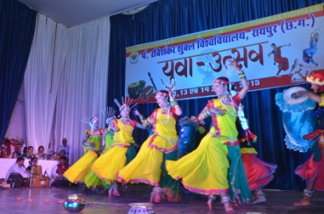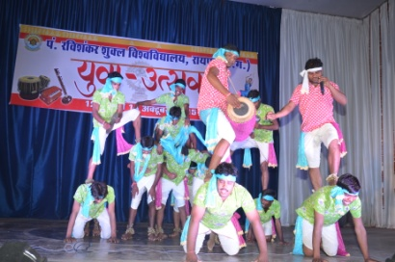
5.9.1 No. of students participated in Sports, Games and other events:
State/ University level | 284 | National level | 299 | International level | 0

No. of students participated in cultural events:
State/ University level | 40 | National level |  | International level | 3  0

5.9.2 No. of medals /awards won by students in Sports, Games and other events:
Sports/Games
State/ University level |  | National level |  | International level | -  12  0

Cultural events
State/ University level | 2 | National level |  | International level | 2  0

5.10 Scholarships and Financial Support:
 | Number of  students | Amount [INR in Lac]
Financial support from institution | 20 | 12.17
Financial support from government | 426 | 31.77
Financial support from other sources | 40 | 82.29
Number of students who received International/ National recognitions | 10 | 5.53

5.11 Student organised / initiatives:
Fairs
State/ University level |  | National level |  | International level | 0  0  0

Exhibition
State/ University level |  | National level | 0  0  1 | International level

5.12 No. of social initiatives undertaken by the students:
5
5.13 Major grievances of students (if any) redressed:
0
Criterion – VI
6. Governance, Leadership and Management
6.1 State the Vision and Mission of the institution:
VISION
- To make quality higher education accessible to all sections of society, including the tribal population of Chhattisgarh
- To provide quality education in the disciplines of arts, humanities, social sciences, natural sciences and other disciplines of learning
- To develop human resource with world class competence and skills in the respective disciplines
MISSION
- To develop the university as a centre of excellence for higher education and knowledge resource
- To promote understanding the value of self-learning, creativity and competence building:
- By providing world-class education through university-teaching departments and schools
- By promoting quality research in university schools and affiliated colleges
- By creating environment conducive to nurture creativity and scientific temper
6.2 Does the Institution has a management Information System:
Yes; To certain extent, the full proposal under process.
6.3 Quality improvement strategies adopted by the institution for each of the following:
6.3.1 Curriculum Development: Please refer Para 1.4 also
- The PRSU revise and restructure curricula on regular basis as per the prescribed guidelines under the supervision of Statutory Bodies.
- Due cognizance was given to the feedback from stake holders and industry.
- The recommendations of UGC and other regulatory bodies are also considered during the process of curricula development and restructuring.
- Nominated peers and external subject experts also provide valuable inputs during the process of curricula development and restructuring.
- Efforts are made to make the curricula congruent with NET and other competitive examination.
- Efforts are made to incorporate new knowledge and development in the curriculum of each subject.
6.3.2 Teaching and Learning
- The University adheres to pre-published academic calendar.
- In regular meetings of the HoDs of various UTDs emphasis is given to make teaching and learning student centric, i.e., learning paradigm.
- All UTDs are provided with Internet connectivity [wired] and WiFi facility for the promotion of ICT based teaching-learning methods.
- Most of the teachers adopt power point presentation and online resources while teaching.
- Promotion of ICT based teaching learning method.
- Many departments have interactive smart boards.
- Subject specific seminars, poster presentations have been internalized as the regular components of the curriculum.
- Symposia/Conferences/Workshops are regularly organized with student participation in each UTD to ensure exposure to new knowledge and also interactions with the peers.
6.3.3 Examination and Evaluation
- The PRSU made a drastic revision and restructuring in the pattern of question paper and answer book and this is being adopted for the 5-year Integrated PG course from this session and it will be adopted for other programs from the next academic session.
- The PRSU declares all examination results online and retrieval mark-sheet online.
- The enrolment, examination form/ document submission and examination fees payment have been made online.
- The performance of students is assessed continuously and comprehensibly through internal tests in addition to end semester examinations.
- The PRSU has strengthened its Grievance Redress mechanism through following ways: (a) The revaluation procedure is transparent and student friendly, but only in the programs having annual examination system; (b) The re-totalling method is adopted for programs with CBCS; (c) The PRSU has provision to issue photocopy of the answer book.
6.3.4 Research and Development
- Establishment of Research Promotion Cell and Patent Cell. This year one patent has been filed at the national level.
- Workshop on IPR is organized.
- Establishment of Plagiarism Cell in the Library. It has been made mandatory to get a clearance from this cell prior to submission of PhD thesis.
- This academic session, seven innovative and path-breaking research centers were sanctioned through grants received under the RUSA and XII Plan.
- Entrance examinations are conducted for admission into PG Programs and research programs, such as MPhil and PhD.
- Rigorous course work is conducted for PhD students and the pass mark is 50% both at the entrance test and also at the course work examination.
- The PhD students write comprehensive reviews while carrying out their course work and at the end they present their review work before a panel of examiners.
- The research work is regularly monitored through the DRC established in each department subject wise.
- It has been mandatory to publish at least one paper in the peer review journal before the submission of the PhD thesis.
- The PRSU organizes national, international, state level symposium/ seminars/ workshops, conferences regularly to keep research scholars and teachers abreast with the latest development in their subject/field of research.
- The research scholars were provided with travel grants to attend international conferences from University’s own resources. This is one of the Best Practices that the University has been practicing since 2010-2011.
- The PRSU motivates the faculty for research linkages at national and international level to carry out collaborative research.
6.3.5 Library, ICT and physical infrastructure/ instrumentation
It has reorganized its e-repository called, “Giyankothi.”
It permits access to IP-based e-resources from remote locations [EZproxy].
Pt. Sundarlal Sharma Library of the PRSU is one of the largest university libraries of the State and one among the leading university libraries of the country.
- Last year the library developed an independent URL and has link with PRSU website.
- It has purchased 3267 books in 2015-2016.
- The library is equipped with ICT and online resources [Please see screen shot below], such as e-journal, e-book, e-thesis, and e-database etc.
- New departmental buildings were inaugurated.
- Buildings of few departments were expanded.
- Arts block was under renovation.
- New hostels are under construction.
- Utility center building was inaugurated (Date of Inauguration: 16 November 2015).
- Seminar halls in Life Science and Pharmacy buildings were constructed.
- The golden jubilee gate was inaugurated (Date of Inauguration: 16 November 2015)
- The NCNR is the only center in the whole of the Central and the Eastern India that boasts of having state-of-the-art sophisticated equipments [purchased in 2014-2015].
- NMR,
- LC-MS-MS,
- HPTLC,
- AAS,
- FTIR,
- PCR,
- RT PCR to name a few.
- These equipments are housed under the same roof. This is considered to be a unique facility developed with the efforts of the University through IRHPA scheme of the DST, New Delhi. The facility is open for researchers of whole of Chhattisgarh.
6.3.6 Human Resource Management
- The VC of the PRSU chairs review meetings of each section and department of the University to ensure optimization of human resources. He monitors progress of various assigned and designated work assignment personally.
- Facilities and benefits, such as loan for purchase of vehicle/ computers/ grains etc. are extended to enhance cordial and happy-go-lucky work culture in the university.
- The best performing non-teaching and teaching staff are respectively honoured every year on the occasion of the auspicious foundation day of the university. Certificates of appreciation are awarded to the non-teaching and teaching staff.
- Workshop and hands on training programs are organized for the augmentation of the computer skills of the support staff.
- In exceptional conditions financial help is forwarded to the employees suffering from serious health problems even if they have opted for MA.
- The University practice Self-Appraisal Method (PBAS) to evaluate the performance of the faculty in teaching, research and extension programmes.
- The IQAC computes Academic Performance Indicator (API) as per the guidelines issued by the UGC. The API is regularly used the implementation of CAS.
6.3.7 Faculty and Staff recruitment
- Periodically the University fills in vacant teaching and non-teaching positions. The process of recruitment and promotion through CAS will be carried out in the next session.
- The IQAC played a key role in designing and finalization of online application form.
- The IQAC is involved in designing API calculators.
- Contract teachers and guest faculty have been appointed for the current session against the vacant posts.
- The University encourages appointment of visiting professors.
- The process of appointment of faculty is transparent and reliable.
6.3.8 Industry Interaction / Collaboration
The University has very active University Industry Partnership Council (UIPC) established in 6th July 2012. It regularly conducts interaction meetings with the local industrialists. On 2 February 2014, the Hon’ble VC of PRSU addressed the gathering of officials and entrepreneurs of Chhattisgarh during their Corporate Social Responsibility (CSR) Meet and apprised them about the need for carrying out CSR activities under the banner of the UIPC, PRSU. The results of such meetings often bear fruits. One hostel for boys is being constructed [2000 m² constructed area] with grant of INR 400.00 lac received from Power Grid Corporation of India Ltd. A MoU has been signed with the Power Grid Corporation that will remain in force till 31st March 2017.
In summary, the UIPC of the University is incessantly active to strengthen the bond between the PRSU and the local Industries.
Our target is to strengthen the bond between the University and Industry. We have planned to organize sensitization programs involving all stakeholders. Further, we have also planned to organize workshops and seminars at regular intervals with the idea that the concepts and objectives of the UIPC are not easily forgotten or dismissed as unimportant if it is not in the direct view of the Industrial Conglomerates.
In many UG and PG programs students visit local industry to have onsite experience of industrial setup, management, work culture and technical skills.
6.3.9 Admission of Students
- The PRSU publicizes admission advertisement widely in the print and electronic media, including the university website.
- The application is received online for all UG and PG courses of the UTDs.
- An entrance test is conducted for all PG programs.
- Many departments organize joint career counselling for students of related subjects for selecting the right academic programs.
- The prospectus provides detail accounts of the academic programs and specializations available in UTDs.
- The admission notice for MPhil and PhD program is also widely publicized in both print and electronic media, including the university website.
- Admission to all research programs are made on the basis of entrance test.
- For PhD program students are admitted only when they succeed in the Course Work examination.
- The names of successful candidates are published in the university website.
- Admission in the professional programs is made following the guidelines of the respective regulatory bodies.
6.4 Welfare schemes for:
The PRSU has number of welfare schemes for the teaching faculty, non-teaching staff and students. The details are outlined below:
Teaching Faculty | - Loan for purchasing vehicles  - Loan facility from Teachers Benevolent Fund [TBF]  - Disbursement of CPF advance  - Disbursement of CPF part final  - Soft loan for buying computers  - Soft personal loan  - Soft house loan  - Medical reimbursement  - Tuition fee refund  - Pension and gratuity
Non teaching | - Lowest interest rate loan for purchasing vehicles  - Disbursement of CPF advance  - Disbursement of CPF part final  - Festival advance  - Grain advance  - Soft loan for buying computers  - Soft personal loan  - Soft house loan  - Medical reimbursement  - Tuition fee refund  - Pension and gratuity
Students | - Free NET/SET and Remedial Coaching classes for SC/ ST/OBC and Minority  - Free health check up  - Free medicine  - Students welfare fund  - Travel grant to research students for attending international conference organized in foreign countries and India  - Scholarships to MPhil and PhD students

6.5 Total corpus fund generated:
DD
6.6 Whether annual financial audit has been done:
Yes |  | No

6.7 Whether Academic and Administrative Audit (AAA) have been done?
Audit Type | External |  | Internal
 | Yes/No | Agency | Yes/No | Authority
Academic | Yes | Mock NAAC Peer Team consisting of real NAAC assessors | Yes | IQAC Team consisting of real NAAC assessors and IQAC members
Administrative | Yes |  | Yes

6.8 Does the University/Autonomous College declare results within 30 days?
For UG Programs
Yes |  | No

For PG Programs
Yes |  | No

6.9 What efforts are made by the University/ Autonomous College for Examination Reforms?
- The PRSU has undertaken number of examination reforms in the last five years.
- Introduction of grading and credit system in the UTDs and all affiliated colleges.
- Introduction of choice-based credit system in the UTDs.
- Drastic restructuring in the pattern of question paper and answer book.

6.10 What efforts are made by the University to promote autonomy in the affiliated/constituent colleges?
- The PRSU provides autonomy to its affiliated colleges within the prevailing statutory provisions.
- Currently the University has SIX autonomous colleges under its jurisdiction.
- The university promotes other affiliated colleges to apply for obtaining autonomous status.
- The university extends all out help and cooperation during the inspection, by regulatory bodies, of these autonomous colleges.
- The PRSU provides following academic and administrative autonomy to its affiliated colleges:
- Promotion research and development activity.
- Introduction of new academic programs, new courses and elective papers in existing programs for autonomous colleges.
6.11 Activities and support from the Alumni Association:
- The PRSU has a registered umbrella alumni association.
- The PRSU has registered [some are yet to register] alumni association in individual UTDs.
- The alumni association of individual departments are affiliated to the Umbrella Alumni Association.
- Regular meetings of the alumni associations are held.
- The alumni give feedback on academic and administrative aspects of the University.
- The alumni support their Alma matter by donating fund.
- The alumni association participate in academic activities, such as conference and symposia actively and often act as co-sponsors.
- The alumni fees/membership has been internalized in the admission procedure.
6.12 Activities and support from the Parent – Teacher Association:
- The formal/registered Parent-Teacher Association does not exist.
- However, regular meetings of the Parent-Teacher are held every year in the UTDs.
- The parents actively participate in the feedback system of the university.
- In few departments, parent teacher association exists.
6.13 Development programmes for support staff:
- The PRSU conducts training programs for the non-teaching support staff with the objective to enhance their professional competency and working skills.
- The technical personnel are trained for new sophisticated equipments.
- They are allowed and encouraged to attend training programs arranged elsewhere.
- They are encouraged to organize and participate in cultural and sports activities.
6.14 Initiatives taken by the institution to make the campus eco-friendly:

The flagship program of the hon’ble PM, “Clean India Movement (स्वच्छ भारत अभियान)” was implemented on the campus.
- The university conducts regular Shramadan programs.
- The PRSU observes International Environmental Day on 5th June every year.
- The University has declared the university campus as “no horn please” zone.
- The University has declared the university campus tobacco free.
- The University has declared the university campus as plastic free zone.
- The University regularly carries out plantation drive in the campus.
- The PRSU has made appropriate arrangement for augmenting water recharging by digging ponds for the purpose.
- The PRSU is carrying out green audit for the campus.
- The PRSU carried out survey of the vegetation on the campus.
- The PRSU carried out survey on the exotic mollusc pests.
- The UTDs have nominated energy monitors from among the students in each class for optimization of power consumption.
- The PRSU has substituted halogen lamps on its campus by LED lamps.
Criterion – VII
7. Innovations and Best Practices
7.1 Innovations introduced during this academic year which have created a positive impact on the functioning of the institution. Give details.
- Best Teacher Awards for academic excellence in each category of teachers belonging to Science Streams and Social Science Streams
- Inception of Center for Basic Sciences
- Establishment of seven (7) Innovative Path-breaking Research Centers
- Inauguration of utility Center
7.2 Provide the Action Taken Report (ATR) based on the plan of action decided upon at the beginning of the year:
Plan of Action | Action Taken
- To continue to identify and reward best teachers | The best academically performing teachers in three different levels from science and social science streams were identified separately.  They were awarded with trophy/certificate of appreciation ceremonially in important events on the campus
- Implementation of CBCS | Implementation process ratified and implemented from the academic session 2014-16 [last session]
- Establishment of innovative and path-breaking research centers | Implemented; Seven such centers have been established from this session
- Strengthening of instrumentation facility | State-of-the-art equipments, namely NMR, LC-MS-MS procured; the installation of NMR is pending.
- Establishment of CBS | Established; Forty students were enrolled in the first batch
- Strengthening of linkages with national and international institutions and organizations | MoUs signed

7.3 Give two Best Practices of the institution (please see the format in the NAAC Self-study Manuals)
*Provide the details in annexure (annexure need to be numbered as I, II, III)
 | Annexure-I
1. | Title of the Practice
 | Research Scholar Funding for Attending International Conference Abroad and in India
2. | Goal
- To facilitate participation of research scholars in international conference
- To instil confidence within the research scholars to present their research findings independently before international audience
- To create a sense of pride within them as they represent their country abroad
3. | The Context
- Normally it has been observed that research papers of research scholars are accepted for presentation in various international symposia and conferences. The candidates send their grant applications to different national and state levels funding agencies for financial support. Sometimes they succeed in getting 50% support only. Eventually they fail to attend the conference due to lack of complete support.
- Therefore, it was thought worthwhile to introduce the practice of research scholar funding for attending international conferences abroad and in India.

4. | The Practice
- The practice of research scholar funding is well publicized in the beginning of each academic session.
- The candidates facing difficulties in getting full support to attend international meeting send their applications to the administrative section of the university.
- The applications are scrutinized by the Grants Cell and are placed before a recommending committee constituted by the Vice-Chancellor.
- The applicants were awarded with the funds after considering the merits on case to case basis.
- Finally the administrative and financial sanctions are granted and funds are released to the candidate as an advance.
5. | Evidence of Success
 | - The practice of awarding funds to research scholars was initiated in the financial year, 2010-11 and the number of beneficiaries is highlighted below.
6. | Problems Encountered and Resources Required
- Problems Encountered: None, as everyone welcomed the practice. It was unanimously resolved by the Executive Council of the University to initiate the practice with immediate effect.
- Resources Required: Funds and administrative and secretarial support for processing of applications. The Grant Cell of the University handles the latter effectively.
7. | Notes
 | - This best practice can be emulated by other universities of the country.
8. | Contact Details
Name of the Vice-Chancellor: | Prof. (Dr.) S.K. Pandey
Name of the Institution: | Pt. Ravishankar Shukla University
City: | Raipur
Pin Code: | 492010
Accredited Status: Re-accredited | Validity Period: Valid up to January 07, 2016
Work Phone: +91-771-2262857 | Fax: +91-771-2263439
Website: www.prsu.ac.in | E-mail: proskp@gmail.com
Mobile: +91-9724200857

 | Annexure-II
1. | Title of the Practice
 | Best Teacher, Best Department and Best College
2. | Goal
- To identify best performance among PRSU’s teachers, UTDs and affiliated colleges
- To appreciate and celebrate their contribution in public functions of the university, such as Foundation day and Teachers Day
- To create a sense of pride within them
3. | The Context
- In a University set up the performance of an individual teacher, a department and an affiliated college assumed to be normally distributed; some of them occupying either tails of the bell curve. Those in the center of the curve contribute appreciably to the overall growth of a higher education institution. Normally it has been observed that the university fails to appreciate and acknowledge contributions of those people who matter much to the university.
- Therefore, it was thought worthwhile to introduce the practice of identifying those in the middle of the bell curve and glorify their achievements publicly by awarding them with a certificate of appreciation. Giving monetary reward is immaterial for them. What matters much is that the apex body of the university cares to acknowledge their contributions in any ceremonial public function.
4. | The Practice
- The identification of the best performance of the above stake holders is carried out by the IQAC.
- The IQAC developed very robust matrices to do this after lots of meetings and discussions between the IQAC and the Head of the Institution.
- The IQAC announces dates for submission of applications for the best performance awards.
- The best teacher, the best department and the best affiliated college are awarded with running trophies and/or certificate of appreciation ceremonially in important events of the university.
5. | Evidence of Success
- The practice of awarding trophy and certificate of appreciation to the best department and the best affiliated college was first initiated in 2014 based on their performance in the session 2013-14. These awards were distributed on the auspicious occasion of the Foundation Day of the university [1 May]
- The practice was appreciated by everyone.
- The practice continued.
- In 2015-16, the practice of awarding the best teacher in each level separately in two different streams, namely science and social science was introduced for the first time. These awards were distributed on the auspicious occasion of the Teachers’ Day [5 September].
- The IQAC is planning to identify and honour the best performing research scholar of the year from 2017.
- Evidence of appreciation of this practice is available in the social media.
6. | Problems Encountered and Resources Required
- Problems Encountered: None, as everyone welcomed the practice.
- Resources Required: Administrative and secretarial support for processing of applications. The IQAC handles it effectively.
7. | Notes
 | - This best practice can be emulated by other universities of the country.
8. | Contact Details
Name of the Vice-Chancellor: | Prof. (Dr.) S.K. Pandey
Name of the Institution: | Pt. Ravishankar Shukla University
City: | Raipur
Pin Code: | 492010
Accredited Status: Re-accredited | Validity Period: Valid up to January 07, 2016
Work Phone: +91-771-2262857 | Fax: +91-771-2263439
Website: www.prsu.ac.in | E-mail: proskp@gmail.com
Mobile: +91-9724200857

7.4 Contribution to environmental awareness / protection
- Substitution of sodium vapour street lamps on the campus with LED lamps/solar-powered lamps
- Celebration of “World Environmental Day”
- Survey of campus vegetation
- Regular conduct of plantation drive
- Survey of exotic African mollusc pest on the campus
- Water recharge initiative in place
- Conduct of green audit in the campus
7.5 Whether environmental audit was conducted?
Yes |  | No

7.6 Any other relevant information the institution wishes to add (for example SWOC Analysis).
S-O Strategy | W-O Strategy
- Introduction of new vocational UG/PG programs  - Introduction of new modular UG/PG programs in new and existing departments  - Promotion of research on medicinal plants and endemic diseases  - Promotion of faculty to tap international funding for R&D activities | - Need analysis of the local population in terms of program demand  - Opening of new programs and remodeling of programs in the department with low PTR  - Augment the activities of the IPR cell and spread awareness on IPR, Patent and Copyright.  - Promotion and intensification of FDPs
S-C Strategy | W-C Strategy
- Augmentation of outreach activities to enhance credibility of the University  - Develop mechanisms and processes to attract students from foreign countries  - Promotion and augmentation of patentable R&D activities | - Establishment of finishing school  - Activation of full MIS based governance  - Commissioning both administrative and academic reforms

8. Plans of institution for the next year
- Implementation of CBCS in colleges affiliated to the University
- Implementation of the matrix designed to compute performance index of non-teaching staff
- Implementation of the matrix designed to identify the best performer among research scholars
- Strengthening of IPR Cell
- The University envisages to open following programs in new and existing departments:
- P.G. courses in Environmental Toxicology, Biological Chemistry, Cancer Biology, Molecular Modeling and Mathematical Chemistry
- M.Sc. Electronics with following specialization: Digital Electronics
- Specialization in Fuel Geology at Masters level; M. Sc. In Geoinformatics; Diploma in Gemology
- M.Sc. Biostatistics; Diploma in Actuarial Statistics
- P. G. Diploma in Museology
- PG Diploma in Archival Studies and Regional History and Culture
- M.A. in Tourism & Hotel Management
- Diploma in Administrative Law, Cyber Law and Labour Law
- MBA Retailing; MBA International Business
- M. Pharm. Pharmacognosy; M. Pharm. Pharmaceutical Chemistry
- The University has plans to build new infrastructure:
- Record room
- Alumni center
- Environment Science building
- Multi facility fitness center
- International guest house

Signature of the Director, IQAC | Signature of the Chairperson, IQAC

Enclosure-I
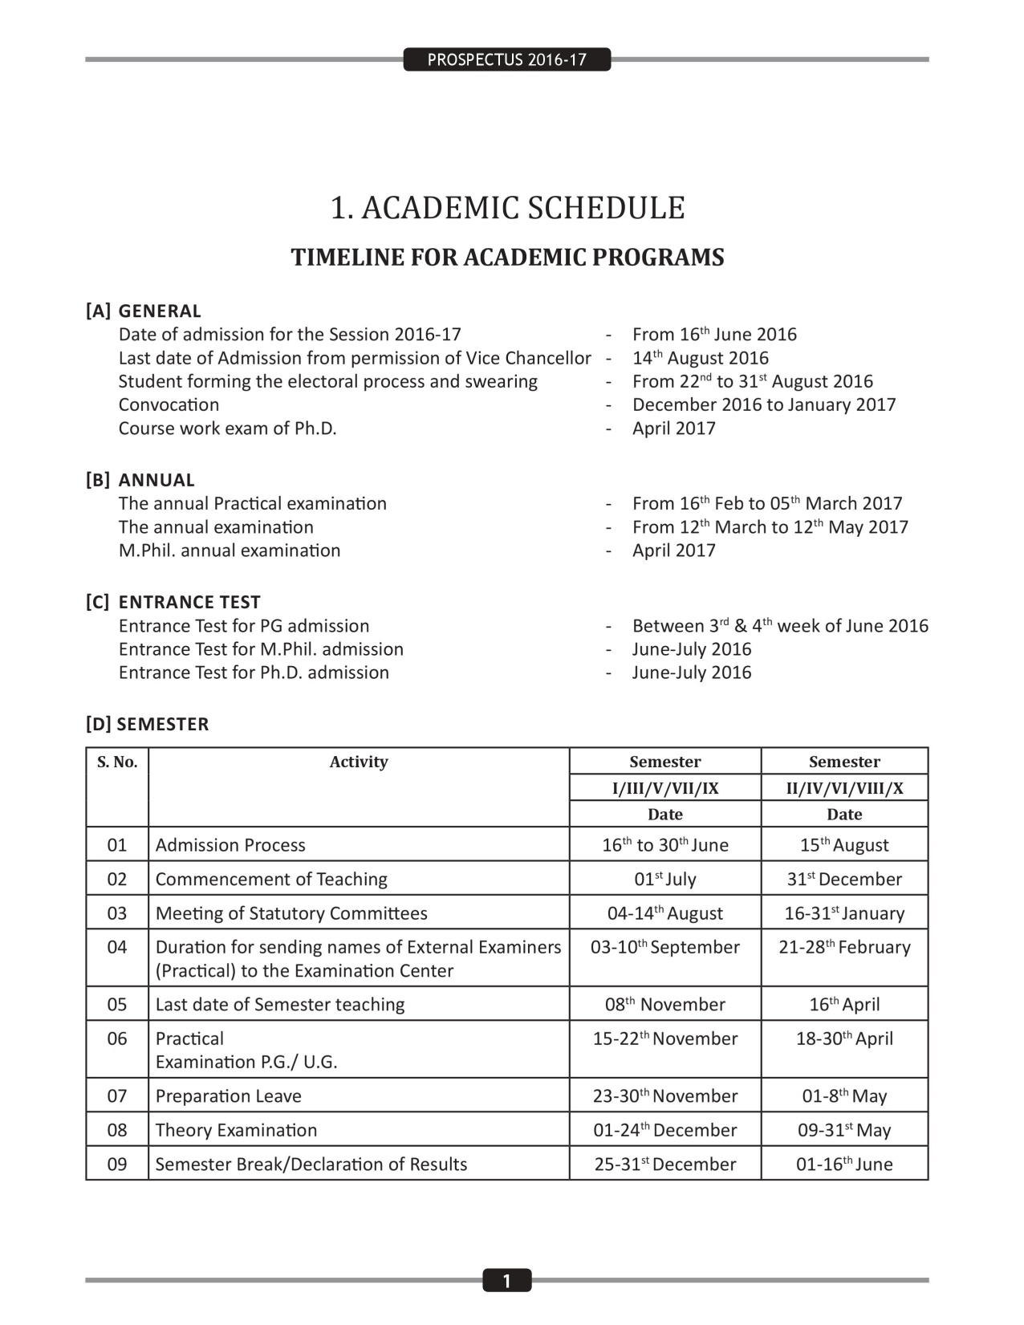

Enclosure-II
An Example
STUDENT FEEDBACK 2014-15
NAMES OF FACULTY

SCORING
4 | 3 | 2 | 1
A | B | C | D
Very good | Good | Satisfactory | Unsatisfactory

No. of students participating –MSc Bioscience (16); MSc Biochemistry (16);MSc Microbiology(14) = Total 46;
Total faculty members [Permanent (10) & Adhoc (04)]=14
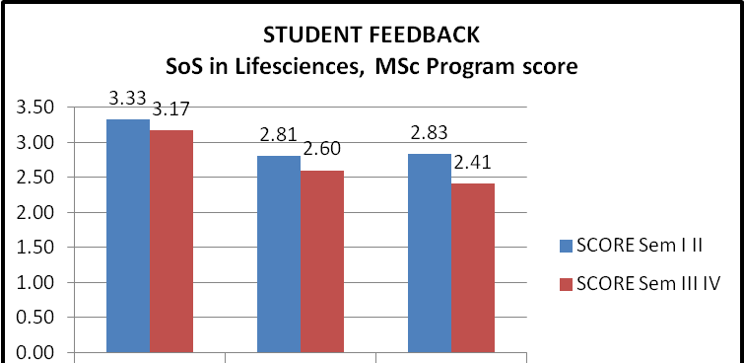

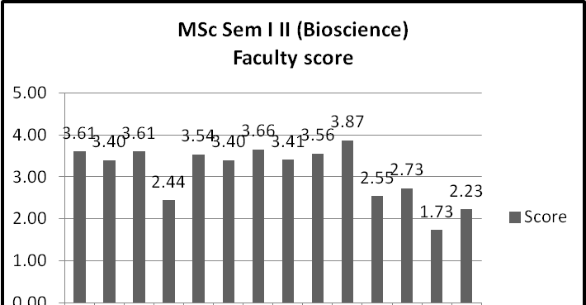
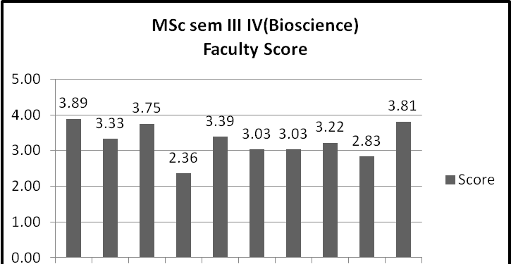

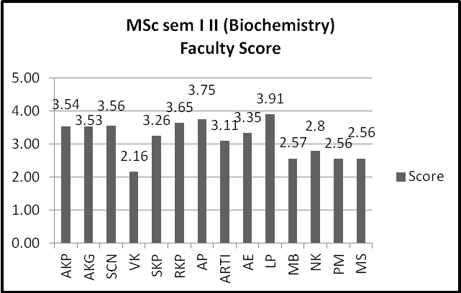
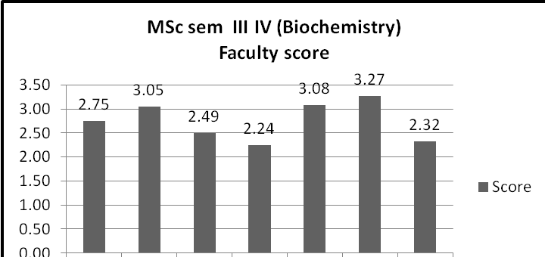
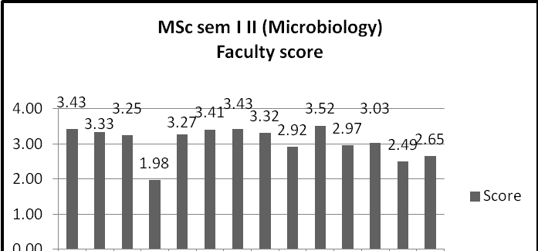
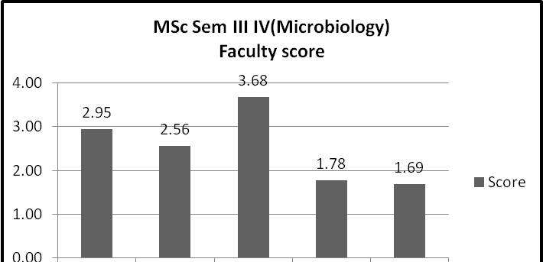
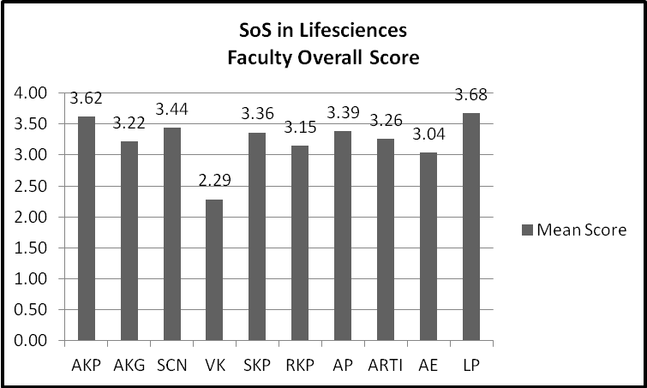
PERCENT RESPONSE
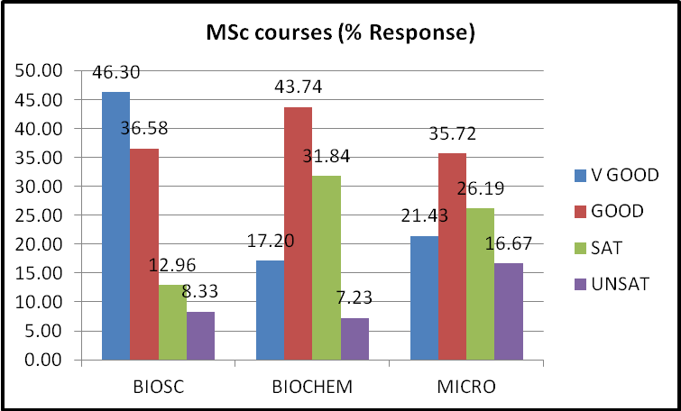
PERCENT RESPONSE TO FACULTY
MSc Biosciences I, II semester
FACULTY | VGOOD | GOOD | SAT | UNSAT
A | 66.67 | 27.78 | 5.56 | 0
B | 54.63 | 33.33 | 9.26 | 2.78
C | 71.3 | 18.52 | 10.19 | 0
D | 21.3 | 25.93 | 28.7 | 24.07
E | 65.74 | 25 | 6.48 | 2.78
F | 55.56 | 31.48 | 10.19 | 2.78
G | 70.37 | 25 | 4.63 | 0
H | 50.93 | 38.89 | 10.19 | 0
I | 63.89 | 27.78 | 8.33 | 0
J | 89.81 | 7.41 | 2.78 | 0
K | 12.96 | 47.22 | 21.3 | 18.52
L | 10.18 | 60.19 | 22.22 | 7.41
M | 3.7 | 19.44 | 23.15 | 53.7
N | 6.48 | 37.04 | 30.56 | 25.93
MSc Biosciences III, IV semester
FACULTY | VGOOD | GOOD | SAT | UNSAT
A | 88.89 | 11.11 | 0.00 | 0.00
B | 61.11 | 16.67 | 16.67 | 5.56
C | 80.56 | 13.89 | 5.56 | 0.00
D | 33.33 | 5.56 | 25.00 | 36.11
E | 47.22 | 44.44 | 8.33 | 0.00
F | 30.56 | 41.67 | 27.78 | 0.00
G | 41.67 | 19.44 | 38.89 | 0.00
H | 66.67 | 8.33 | 5.56 | 19.44
I | 27.78 | 41.67 | 16.67 | 13.89
J | 80.56 | 19.44 | 0.00 | 0.00

MSc Biochemistry I, II semester
FACULTY | VGOOD | GOOD | SAT | UNSAT
A | 62.96 | 28.40 | 8.64 | 0.00
B | 64.20 | 24.69 | 11.11 | 0.00
C | 62.96 | 29.63 | 7.41 | 0.00
D | 22.22 | 33.33 | 33.33 | 11.11
E | 53.09 | 25.93 | 14.81 | 6.17
F | 67.90 | 29.63 | 2.47 | 0.00
G | 77.78 | 19.75 | 2.47 | 0.00
H | 35.80 | 40.74 | 22.22 | 1.23
I | 43.21 | 48.15 | 8.64 | 0.00
J | 92.59 | 6.17 | 1.23 | 0.00
K | 6.17 | 51.85 | 34.57 | 7.41
L | 16.05 | 50.62 | 30.86 | 2.47
M | 17.28 | 37.04 | 29.63 | 16.05
N | 6.17 | 43.21 | 50.62 | 0.00

MSc Biochemistry III,IV semester
FACULTY | VGOOD | GOOD | SAT | UNSAT
A | 26.98 | 47.62 | 25.40 | 0.00
B | 19.05 | 41.27 | 34.92 | 4.76
C | 25.40 | 53.97 | 20.63 | 0.00
D | 14.29 | 34.92 | 36.51 | 14.29
E | 11.11 | 63.49 | 20.63 | 4.76
F | 15.87 | 11.11 | 53.97 | 19.05
G | 28.57 | 52.38 | 17.46 | 1.59
H | 20.63 | 41.26 | 22.22 | 15.87
I | 20.63 | 39.68 | 26.98 | 12.70
J | 44.44 | 38.10 | 17.46 | 0.00

MSc Microbiology I, II semester
FACULTY | VGOOD | GOOD | SAT | UNSAT
A | 65.08 | 17.46 | 12.70 | 4.76
B | 53.97 | 28.57 | 14.29 | 3.17
C | 50.79 | 25.40 | 22.22 | 1.59
D | 7.94 | 25.40 | 23.81 | 42.86
E | 47.62 | 34.92 | 14.29 | 3.17
F | 61.90 | 20.63 | 14.29 | 3.17
G | 66.67 | 14.29 | 14.29 | 4.76
H | 50.79 | 31.75 | 15.87 | 1.59
I | 34.92 | 41.27 | 4.76 | 19.05
J | 63.49 | 25.40 | 11.11 | 0.00
K | 39.68 | 26.98 | 23.81 | 9.52
L | 38.10 | 34.92 | 19.05 | 7.94
M | 20.63 | 33.33 | 20.63 | 25.40
N | 7.94 | 50.79 | 39.68 | 1.59

MSc Microbiology III, IV semester
FACULTY | VGOOD | GOOD | SAT | UNSAT
A | 42.86 | 19.05 | 28.57 | 9.52
B | 22.22 | 39.68 | 9.52 | 28.57
C | 69.84 | 28.57 | 1.59 | 0.00
D | 0 | 15.56 | 37.78 | 46.67
E | 2.22 | 33.33 | 4.44 | 60.00
ACTION TAKEN REPORT
The overall score given by students on the performance of the faculty was circulated among the faculty members including contractual faculty with the request for improvement in teaching quality.

Professor-in-charge
Student feedback, SLS

Key to Abbreviations:
CAS - Career Advanced Scheme
CAT - Common Admission Test
CBCS - Choice Based Credit System
CE - Centre for Excellence
COP - Career Oriented Programme
CPE - College with Potential for Excellence
DPE - Department with Potential for Excellence
DD - Data deficient
GATE - Graduate Aptitude Test
NET - National Eligibility Test
PEI - Physical Education Institution
SAP - Special Assistance Programme
SF - Self Financing
SLET - State Level Eligibility Test
TEI - Teacher Education Institution
UPE - University with Potential Excellence
UPSC - Union Public Service Commission

